Password Protection System

Team Members:

* Sanjay G -230121049
* Akaash S S – 230103009
* Eniyan E - 230121020
* Mohnish Raja - 230103063

Objective: Build a simple password protection system using a set of switches or buttons as inputs to enter a password.

Features:

1) System should have a provision to set/reset the password.

2) Password should be a 4-digit decimal number.

3) Entering the wrong password consecutively for 3-times will permanently lock the system, unless unlock by the admin.

Requirements: It should be built by combinational and sequential circuit components only.

Overall Circuit Schematic

Single bit Schematic

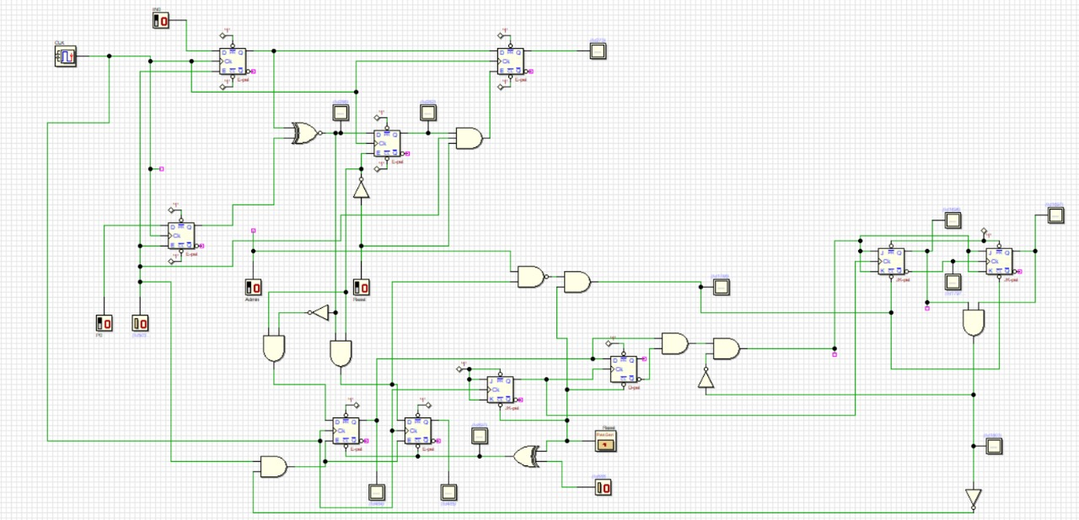

Counter(to count number of incorrect inputs)

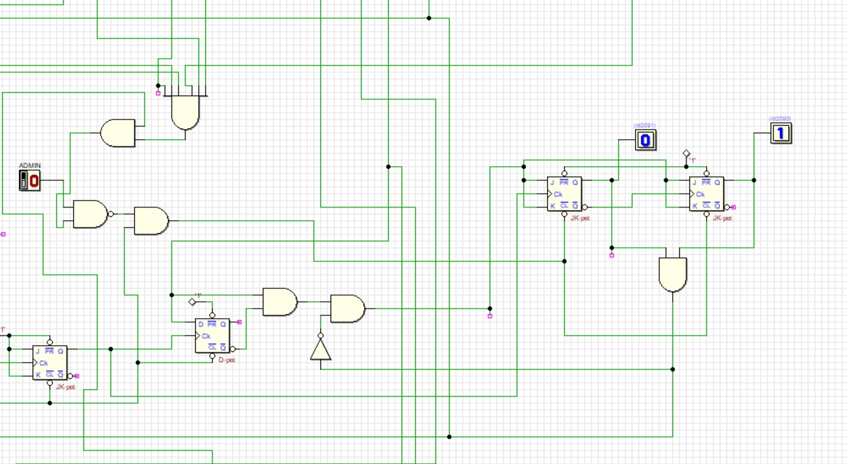

Correct or incorrect output with LED

Reset and enter button Password locked when count=3

Input 16 bit password (BCD)

Try Again Button

